**If-then Scripts:**

**Check the variable**

#!/bin/bash

count=100

if [ $count -eq 100 ]

then

echo Count is 100

else

echo Count is not 100

fi

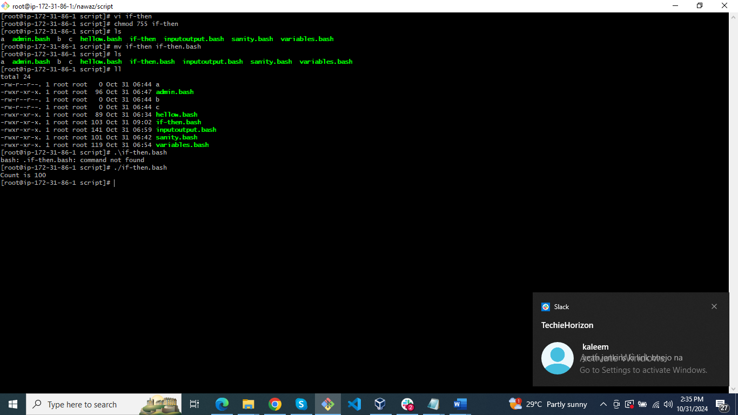

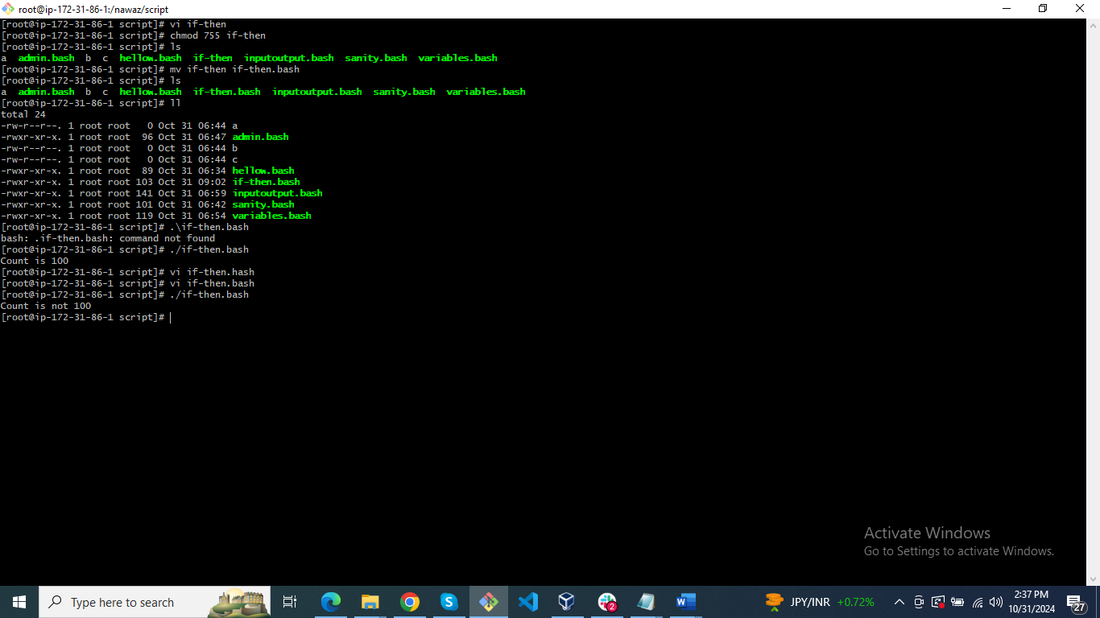

2) Task

#!/bin/bash

clear

if [ -e /home/iafzal/error.txt ]

then

echo "File exist"

else

echo "File does not exist"

fi

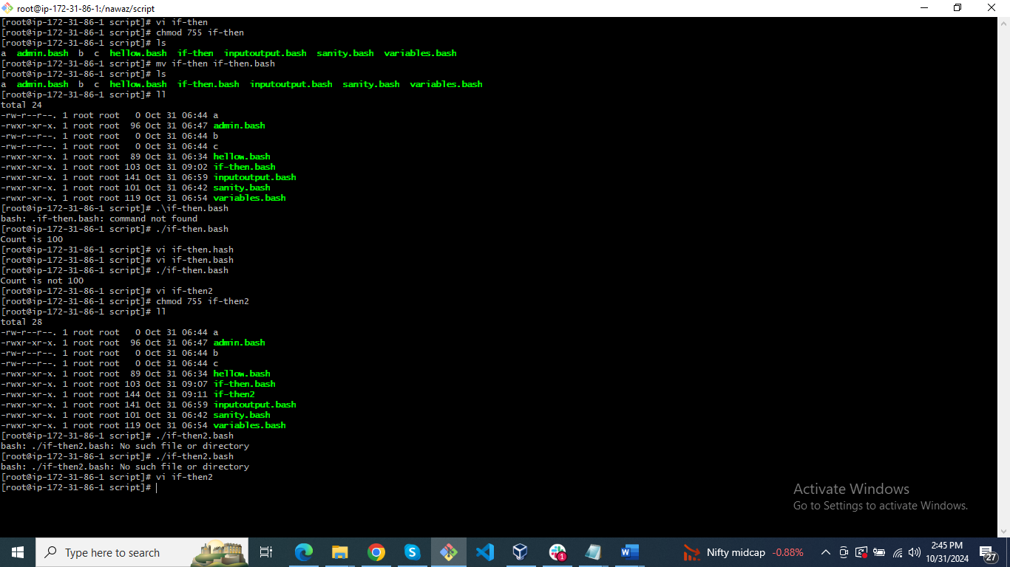

3) Task

#!/bin/bash

a=`date | awk '{print $1}'`

if [ "$a" == Mon ]

then

echo Today is $a

else

echo Today is not Monday

fi



Case-Script

#!/bin/bash

echo

echo Please chose one of the options below

echo

echo 'a = Display Date and Time'

echo 'b = List file and directories'

echo 'c = List users logged in'

echo 'd = Check System uptime'

echo

read choices

case $choices in

a) date;;

b) ls;;

c) who;;

d) uptime;;

*) echo Invalid choice - Bye.

esac



Do While statement

#!/bin/bash

count=0

num=10

while [ $count -lt 10 ]

do

echo

echo $num seconds left to stop this process $1

echo

sleep 1

num=`expr $num - 1`

count=`expr $count + 1`

done

echo

echo $1 process is stopped!!!

echo

